ASSIGNMENT- 4

|  |  |
| --- | --- |
| TEAM ID | PNT2022TMID52179 |
| NAME | MONISHA M |
| ROLL NO | 963019104005 |

Write code and connection in wokwi for ultrasonic sensor. whenever distance is less than 100 cms send alert to ibm cloud and display in device recent events.

Code :

# define ECHO_PIN 2 # define TRIG_PIN 3

Void setup () { Serial.begin(115200);

pinMode(LED_BUILTIN, OUTPUT); pinMode(TRIG_PIN, OUTPUT); pinMode(ECHO_PIN, INPUT);

}

Float readDistanceCM() { digitalWrite(TRIG_PIN, LOW); delayMicroseconds(2); degitalWrite(TRIG_PIN, HIGH); delayMicroseconds(10); degitalWrite(TRIG_PIN, LOW);

int duration = pulseIn(ECHO_PIN, HIGH); return duration * 0.034/2;

}

void loop() {

float distance = readDistanceCM();

bool isNearby = distance < 100; digitalWrite(LED_BUILTIN, isNearby);

Serial.print(“Measured distance: “);

Serial.print1n(readDistanceCM());

delay(100);

}

OUTPUT :

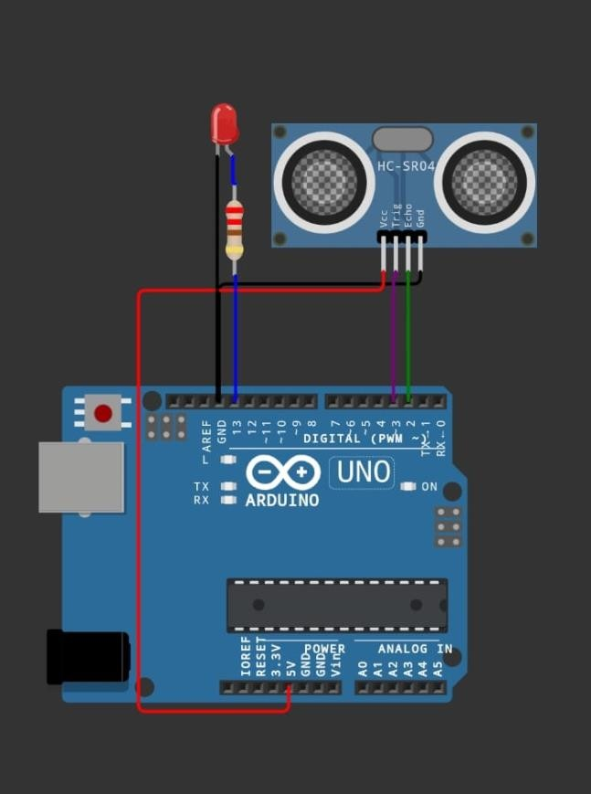

Reference: <https://wokwi.com/projects/290056311044833800>